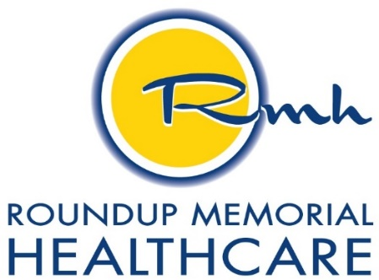

PLAIN LANGUAGE SUMMARY OF FINANCIAL ASSISTANCE POLICY

Roundup Memorial Healthcare is committed to providing financial assistance to persons who have healthcare needs and are uninsured, underinsured, ineligible for government program, or otherwise unable to pay, for medically necessary care based on their individual financial situation.
All providers listed below are covered by the financial assistance policy.
Brynn Bixby, PAC
Valeri Russell, PAC
Deanna Daigrepont, MD
Lorie Hutchison, PAC
Including all contracted providers with Roundup Memorial Healthcare

Financial assistance is available for those that do not have insurance, are underinsured, or it would be a financial hardship to pay in full the out-of-pocket expenses to Roundup Memorial Healthcare. Patient care, which is not medically necessary, including elective, cosmetic, or other care deemed to be generally non-reimbursable by traditional insurance carriers and government payers, shall not be considered eligible for financial assistance.

Financial assistance if determined by a sliding fee schedule (which is based on the National Poverty Guidelines Scale for that calendar year) of the total household income based on the Federal Poverty Level (FPL). Financial Assistance may be available in cases where full payment of outstanding medical expenses could cause serious social and financial hardship to the patient or the household. These circumstances may warrant that an exceptional financial assistance reduction be considered. No person eligible for financial assistance under the Federal Poverty Level will be charged more for emergency or other medically necessary care than amounts generally billed to patients who have insurance covering such care.
Patients may apply for financial assistance by completing the Community Caring Program Application. The application and the Roundup Memorial Healthcare Financial Assistance Policy can be found on our website at www.rmhmt.org. Request for application is also available by calling the Business Office at (406) 323-3337.
Completed applications and supporting documents can be submitted to Roundup Memorial Healthcare Business Office for processing at the following address:
Roundup Memorial Healthcare
Attn: Business Office
PO Box 40
Roundup, MT 59072

Persons needing more information or assistance in completing the Community Caring Program Application may contact a Patient Account Rep at (406) 323-3337.

